CHEMISTRY

SEMESTER ONE EXAMINATION 2005

SOLUTIONS

PART 1

1. C 5. B 9. A 13. D 17. C
2. C 6. C 10. A 14. B 18. B
3. B 7. B 11. A 15. C 19. C
4. C 8. C 12. A 16. A 20. B

PART 2

1.

(a) Equation: SO₄⁻²(aq) + Ba⁺²(aq) → BaSO₄(s)

Observation: Two colourless solutions are mixed and a white precipitate forms.

(b) Equation: A(OH)₃ + OH⁻→ [A(OH)₄]⁻

Observation: The white solid dissolves leaving a clear colourless solution

(c) Equation: 2Cs + 2H₂O → 2Cs⁺ + 2OH⁻ + H₂

Observation: Explosive reaction. A colourless gas is vigorously emitted.
The solid dissolves.

(d) Equation: No reaction

Observation: No changes

2.

Molecule or ion | Structure formula (showing all valence electrons) | Sketch of shape | Name of shape
carbonate ion | 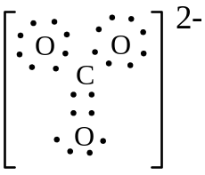 | 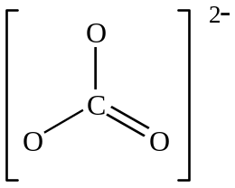 | PLANAR  TRIANGULAR
arsenic trihydride | 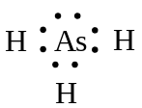 | 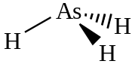 | PYRAMIDAL
selenium dihydride | 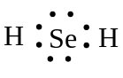 | 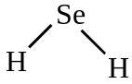 | BENT

3. [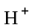] = 10^{−10.5} = 3.1623 × 10⁻¹¹ mol L⁻¹

Therefore [OH⁻] = 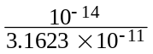 = 3.1623 × 10⁻⁴
= 3.16 × 10⁻⁴ mol L⁻¹

4.
Explanation
The chips have less surface area in total so there are less effective collisions than with the powder giving a slower reaction.
The molecules move faster at higher temp - more collisions - faster rate.
Also more molecules will possess the activation energy
required - faster rate.

Catalyst provides a lower activation energy path - so more particles will possess at least this energy so they will now react - faster rate

5. (a) 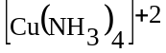 or similar

(b) H₃PO₄

(c) SiO₂ or SiC

(d) Iodine (I₂)

6.
 | Your chemical test.  Describe fully | What you would observe in each case
solid zinc sulfate  and  solid zinc nitrate | Dissolve each  solid in water  Add to each solution  a solution of  Ba⁺² , Sn⁺², Pb⁺² or  Hg⁺² ions | with ZnSO₄  A white precipitate forms
solid zinc sulfate  and  solid zinc nitrate |  | with Zn(NO₃)₂  No precipitate forms
solid copper (II) carbonate  and  solid copper (II) chloride | 1.  Add dilute HC or  H₂SO₄ to each  or  2.  Heat strongly | with CuCO₃  1.  Solid dissolves to green solution - colourless gas released.  2.  The green solid goes black
solid copper (II) carbonate  and  solid copper (II) chloride | 1.  Add dilute HC or  H₂SO₄ to each  or  2.  Heat strongly | with CuC₂  1.  The solid dissolves to a green solution but no gas evolved.  2.  Solid does not go black

END OF PART 2
PART 3

1.
(a) Ba⁺² + SO₄⁻² → BaSO₄
n(BaSO₄) = 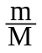 = 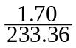 = 7.285 × 10⁻³ mol
n(MgSO₄) = n (SO₄⁻²) = n(BaSO₄) = 7.285 × 10⁻³ mol
Therefore m(MgSO₄) = n × M = 7.285 × 10⁻³ × 120.37
= 0.8769g (5L)
= 175 mg L⁻¹

(b) Mg⁺² + CO₃⁻² = MgCO₃
[Mg SO₄] = 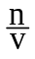
= 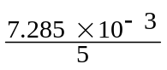 = 1.457 × 10⁻³ mol L⁻¹
n(MgSO₄) in 100 L = c × v
= 1.457 × 10⁻³ × 10²
= 1.457 × 10⁻¹ mol
n(Na₂CO₃ .10H₂O) = n(CO₃⁻²) = n(Mg SO₄) = 1.457 × 10⁻¹ mol
m (Na₂CO₃ .10H₂O) = nM
= 1.457 × 10⁻¹ × 286.15
= 41.7 g

(c) n(Na⁺) in 100 L = 2n(Na₂CO₃ .10H₂O)
= 2.9147 × 10⁻¹ mol
therefore [Na⁺] = = 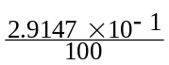 = 2.91 × 10⁻³ mol L⁻¹

2. (a) m(C) = 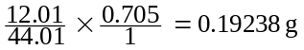 therefore % C = 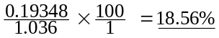
m(H) = 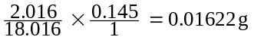 therefore %H = 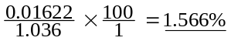
In second sample
m(C) = 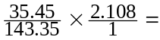 0.5213 g therefore %C = 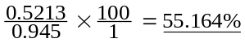
therefore % (0) = 100 - (18.569 + 1.566 + 55.164) = 24.70%

 | C | H | O | C
% | 18.569 | 1.566 | 24.70 | 55.164
n | 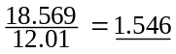 | 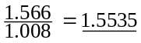 | 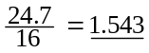 | 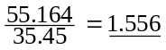
Simplest  Ratio | 1 | 1 | 1 | 1
 | therefore EF = CHOC

(b) n = 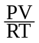
= 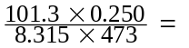6.44 × 10⁻³ mol
M = 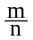 = 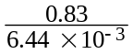 = 128.88
= 1.29 × 10²

(c) EF = COHC
therefore EF MW = 64.47 g mol⁻¹
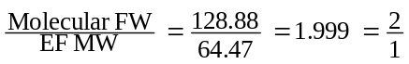
therefore Molecular Formula = 2 E.F = C₂O₂HC₂

3. (a) 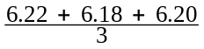 = 6.20 mL

(b) H⁺ + OH⁻ → H₂O
n(OH⁻) = c × v = 0.1031 × 0.0062 = 6.3922 × 10⁻⁴ mol
therefore n(H⁺) in 20 mL = 6.3922 × 10⁻⁴ mol
therefore n(H⁺) in 250 mL = 6.3922 × 10⁻⁴ × 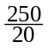 = 7.99025 × 10⁻³ mol
n(H⁺) in 1.0308 g sample is 7.99025 × 10⁻³ mols
therefore M = 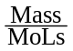 = 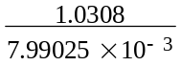
= 129 g mol⁻¹

(c) Taking more care is not a modification.
Modify to give less significant error from the burette reading by
• Increasing the titration volume by reducing the NaOH concentraton
• Increasing the titration volume required by increasing the acid concentration

